Children’s Ministry Year at a Glance 2021-2022
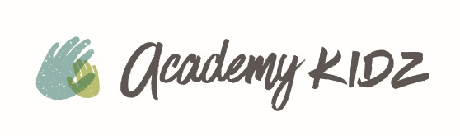
2021
CM Volunteer Trainings – Sept. 12th (12:30 – 2PM Lunch) & Sept. 14th @ 6PM
Kidz Choir starts Sunday, September 12 @ 11AM

Parent/Child Baptism Class – October 17th (1:30PM – 3PM)
SPLASH Baptism Service – November 7th Splash 5PM

Soundcheck with Kidz Choir Thursday evening October 21st
Kidz Choir sings in all services - October 24th

Trunk or Treat – NS Saturday, Oct 30th 10AM – 1:00PM WS – Sunday, Oct 31st
Kidz Christmas Choir rehearsal - Saturday, December 11th 9:30AM – 11:00AM
Kidz Christmas Program – Sunday, Dec. 12th - all services; Preschool @ 9:30 & 11

2022
Parent/Child Baptism Class – Sunday, January 23rd 1:30PM – 3:00PM

Camp Como Snow Camp – February 4th & 5th

Soundcheck for Kidz Choir Thursday evening February 10th
Kidz Choir sings in all services – February 13th

Kidz Choir Rehearsal – Saturday, April 9th 9:30 AM – 11:00 AM
Palm Sunday Kidz Choir sings in all services – Sunday, April 10th
EASTER Sunday, April 17th – Projected Grand Opening CME

Parent/Child Baptism Class - TBD
SPLASH Baptism Service - TBD
Parent/Baby Dedication Class - Saturday, April 30th 9:00AM – 10:30AM
Mother’s Day Parent/Baby Dedication – Sunday, May 8th all services

VBS Trainings - Wednesday, May 25th 6PM-8PM & Saturday, June 11th 10AM – Noon
VBS – June 13th - 16th (9AM – noon) w/ Family Fun Night June 16th 6PM – 8PM
Prospector Camp 2 at Camp Como – July 2022

